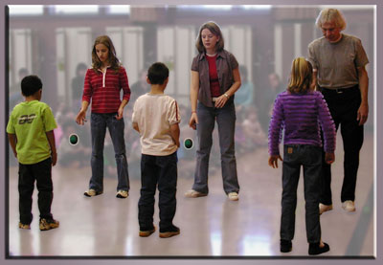
X
-
Vis
-
A
-

Bal
Presented by Chua Muhammed Hadi and Sumiati Said from Singapore.
This husband and wife team has been working with children since 1990.
They have been working with children with Bal-A-Vis-X for the past three years with successful results. They have taught BAVX in S'pore, Jakarta, Australia and Malaysia.
They are both professional members of the Educational Kinesiology, USA.

Bal-A-Vis-X is a series of Balance / Auditory / Vision / eXercises, of varied complexity, most of which are deeply rooted in rhythm. These exercises require full- body coordination and focused attention.
The program utilizes sand-filled bags, racquetballs, and balance boards. It demands cooperation, promotes self-challenge, and fosters peer teaching. It is school friendly and just plain fun.
Bal-A-Vis-X is for every student. It is effective for students who are labelled:-
Learning disabled - cognitive integration improves, Regular – academic success improves yet requires less effort,
ADD / ADHD – impulsivity decreases and attention span increases, Behaviourally disordered – behaviour ‘’settles”
Gifted – physical coordination improves and stress headaches diminish.

Benefits:
Bal-A- Vis-X benefits students whose auditory Bal-A-Vis-X is for students whose visual acuity may be skills are inadequate for academic success. 20/20, yet whose vision remains
Such students “ hear “ but do not attend to the deficient in: *Ocular motility (tracking)
precise details of *Pronunciation *Visual form perception (discrimination of details).
*Verbal instructions. *Discussions, *Binocularity (teaming)
For these students, the rhythmic patterns of Bal-A-Vis-X
create a new awareness of the nuances of sound.

For all students the gains in eye-hand co-ordination and Growth in overall confidence, hence, self-esteem,
are readily available.
- It is also suitable for adults of any age who wish to increase their mobility or sports related performance.

Who is the workshop suitable for?
PT’s, OT’s, Brain Gym Instructors, Teachers, Counsellors, Neurologists, Recreational, Educational, Speech Therapists, Physical Education Teachers, Care Workers and Parents.
Once trained, adults can use BAVX with their own students /children/ clients /patients – in their own settings.

Training Hours: total, 17 hours
Level 1, Foundation Exercises (9 hours), Level 2, Intermediate Exercises (6 hours)
Adaptive BAVX for Special Needs and Seniors (2 hours).

Date and time: Saturday 12th and Sunday 13th October 2013, 9:00am to 5:30pm. Snacks provided.
Venue: The Therapy Playroom: n89 Jalan Dogan, Lrg 3 (1st Floor), Off Batu Kawa Rd.
Fee: Special Kuching Price, RM900 or book with 3 persons for only RM850 each.
****Free set of balls for each participant****
Early Bird special until 31st August. RM800 or book with 3 persons for only RM750 each!

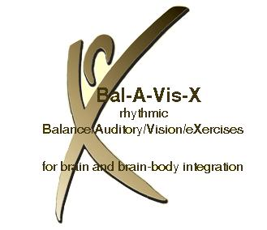
Creator Bill Hubert: “Learning Bal-A-Vis-X is a painstaking process calling for patience and perseverance. It's a campaign, similar to acquiring expertise in fine arts or martial arts. The result of that patience and perseverance will be Bal-A-Vis-X expertise. The result of that expertise will be your ability to change lives for the better. A worthy exchange.”

BAVX website: www.bal-a-vis-x.com

For booking and enquiries, contact Rachel Mill, 0n 0146388392
or bitemyapple81@icloud.com
or like our facebook page, facebook/thetherapyplayroom.com

The Therapy Playroom.
Registration form
Bal-A-Vis-X workshop 12/13th October 2013.
Please complete a booking form for each person.
All fees inclusive of tea breaks and a set of balls.
- Regular price RM900
- Regular group of 3 people, RM850 each.

*early bird must be paid by August 31st.
- Early bird RM800 *
- Early bird group of 3 people, RM 750 each.*

Name:

Address:

Contact number: or

Occupation:

Email address:

Payment:
Cash / bank transfer

Paid Amount: RM On date:

How did you hear about this workshop?:

What do you hope to gain from this BAl-A-Vis-X workshop? .

Payment information, cash or banking

(James a/l Santhiagu)
Bank name: Maybank
Bank account number: 161088481337

The Therapy Playroom offers a wide range of services for children and adults with special needs, would you like to know more about:
- Speech therapy
- Physiotherapy
- Brain gym
- The Listening Programme
- Dyslexia Tuition
- Building Block Activities
- Rhythmic Movement Training
- Our specialised movie and support nights.

